Panama Canal

Directions: During the early part of the 20th century, the Panama Canal was the subject of hundreds of editorial cartoons. Take a closer look at four of these images, which are reprinted below. Then answer the questions that follow.

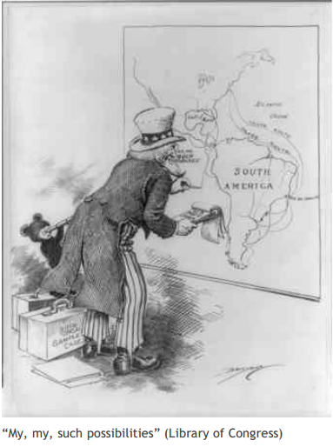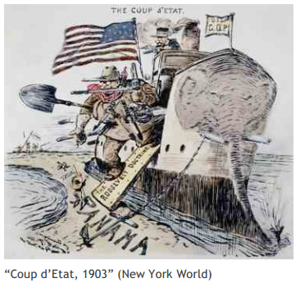

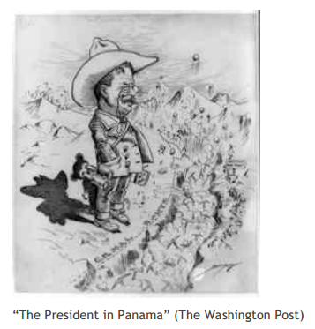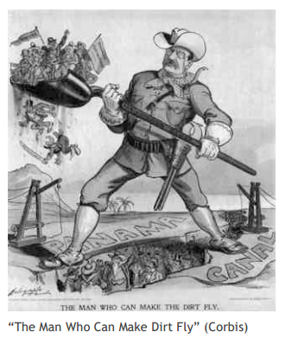

- How is Teddy Roosevelt portrayed in each of these cartoons? Which depiction is the most favorable? The most negative? Point to specific symbols and details in each image to support your answer.

- What comment is each cartoonist making about Roosevelt's involvement in the Panama Canal project?

- How is Panama portrayed in the Coup d'Etat cartoon? Does this cartoonist appear to support or oppose the "Roosevelt Doctrine"?

- What images of America and its role in global affairs are presented in these cartoons? Is there a variety of viewpoints about America as a global power or a consistent point of view among the cartoonists? Discuss.

