Age of Exploration: 1500-1800
- Age of Exploration – Early 15th to 17th century when European sailors explored many parts of the world, especially North America. Explorers were in search for ________________________
Vocabulary | Definition
Global Age | a time when all civilizations can be in contact with the others around the world. Beginning around 1400.
Explorers | a person who travels in search of geographical or scientific information
Compass | a device for determining directions by means of a magnetic needle or group of needles turning freely on a pivot and pointing to the magnetic north.
missionaries | a person undertaking a mission and especially a religious mission
Astrolabe | a compact instrument used to observe and calculate the position of celestial bodies before the invention of the sextant
sea route | route taken by sea by explorers
Trade | dealings between persons or groups.  (1) : the business of buying and selling or bartering commodities
Cargo | the goods or merchandise conveyed in a ship, airplane, or vehicles.
Circumnavigate | To circumnavigate a place, such as an island, a continent, or the Earth, is to travel all the way around it by boat or ship.
Armada | a word of Spanish origin similar to navy or fleet
Conquistador | one of the Spanish soldiers, explorers, and adventurers who took part in the conquest of large parts of the Americas and Asia, bringing them under Spanish colonial rule between the 15th and 19th centuries.

- In the 1400’s Europeans began to sail across the globe.
Why Explore?
Crusades and journeys of Marco Polo exposed Europeans to new technologies, products, and culture.
1. ____________=nutmeg, cinnamon, ginger, pepper
2. ____________
3. ____________=medicinal and “recreational” use

The OTTOMAN EMPIRE
- Europeans couldn’t travel across land because the ________________________would attack them.

THE PORTUGUESE
- FIRST to explore the western coast of _______________!
- Looked for a route around Africa to _________________.

POP QUIZ!!!

- In the 1400’s _____________ began sailing across the globe.
- Europeans wanted Silks and Spices from _______________.
- Europeans sailed around Africa to avoid ___________________________.
- What country was the first to go around Africa?

CAUSE OF EXPLORATION:
- People want _____________

Exploration
- Europeans difficult time traveling east
- Problems with Ottomans Empire
- No longer safe to travel
- Still wanted products from Asia
- Started to look for alternate route
- Portuguese
  - Began to explore west coast of Africa
  - Africa to India
  - This established major trade route

Two Main Players in Early Exploration
- ________________
- ________________

EFFECT OF EXPLORATION
- ____________________

NEXT STEP?
- Set up colonies
- Under control of a country.
- Ruled by the “mother country”
- Colony provide goods and profit to the “mother country”
Colony:
- A territory under immediate control of a country.
- The territory is ruled by the “mother country”
- The territory must provide goods and profit to the “mother country”
COLONIES BRING WEALTH AND NEW PRODUCTS HOME TO THEIR MOTHER NATIONS.
Vegetables of the New World:
- ___________________
- ___________________
- ___________________
- ___________________
- ___________________

Triangular Trade:
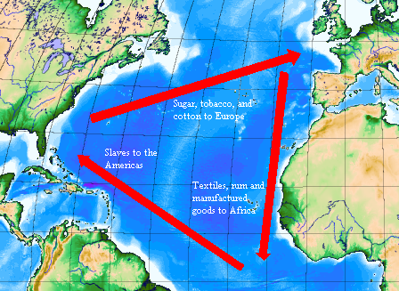
________________________________________________________________________________________________________________________________________________________________________________________________________________________________________________________________________________________________________________________________________________________________________________________________________________________________________________

Christianity Spreads:
The Three G's
- ________________
- ________________
- ________________
Technological and Scientific Advances:
- made it easier to explore
Vocabulary | Definition
CARAVEL | A BOAT WITH SQUARE SAILS TO TRAVEL LONGER DISTANCES.
MAPS | New and ACCURATE maps helped explorers find their way.
GUNPOWDER | Explorers used gunpowder to protect themselves.  They also had to hunt for food.

