Athens and Sparta Worksheet
Ancient Greece wasn't one large empire but a collection of smaller city-states. The term the Greeks used was polis, which means “city-state”. A polis was bigger than a city but smaller than a state. They were scattered throughout the Mediterranean area. Some were sea-ports while others were more inland. The two most famous city-states were Athens and Sparta. Although the people living in these city-states were all Greek, each city-state did different things and had different beliefs. Lets examine these differences by looking at two city-states.
Athens- was the most famous of all the city-states of ancient Greece. It was the birthplace of democracy and home to great philosophers like Plato and Socrates. It was also home to historians, scientists, mathematicians, and other great thinkers. Athens was famous for its giant fleet or ships, which they used to help defeat the Persians. A great rivalry with another city-state, Sparta led to the Peloponnesian War. This war eventually ended in a victory for Sparta.

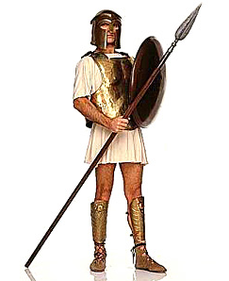
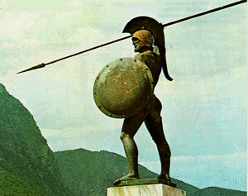

1. What were two important Greek city-states? a) _____________________, b) _____________________

2. What was the Greek word for city-state? ____________________

3. Athens was the birthplace of this important idea… ______________________

4. Who were two famous philosophers from Athens? a) __________________, b) __________________

5. Who won the Peloponnesian War? _____________________

6. What were the Spartans famous for? ___________________________________________

7. What were boy in Sparta expected to be when they grew up? ______________________________

8. Who did the Spartans depend on to complete their manual labor? _____________________

Sparta- had the strongest military of all ancient Greek city-states. The focus of this city-state was constantly on war. Boys were expected to be trained as soldiers, while girls were expected to grow up and bear children who grew up to be soldiers. To make sure that the army got as many Spartan soldiers as it needed, Sparta depended on slaves from nearby settlement to do their manual labor. When the Greeks were at war with Persia, many people turned to the Spartans to ensure their protection.

