Imperialism:
- building empires by
  - ________________ territory and gaining colonies

Economic Origins of Imperialism:
- The Industrial Revolution
  - Industrialized nations took control of less developed nations
    - To gain ___________________ for industry
      - Cotton, coal, metals, etc.
    - To gain markets for goods
      - Manufactured goods could be sold in the colonies
Political and Social Origins of Imperialism:
- _________________________
  - Competition between industrial nations led to a race for overseas empires
- The “White Man’s Burden”
  - Many believed it was their duty to “civilize” people of other nations by introducing Christianity and Western culture
- Social Darwinism
  - Many claimed it was natural for “the weak to be taken over by the strong”
Major Imperial Powers:
- Great Britain
- France
- Germany
- Russia
- The United States
- Japan
Imperialized Areas:
- Powerful industrial nations established empires in:
  - Africa
  - Asia
  - Oceania (Australia, New Zealand, and surrounding islands)
The Scramble for Africa:
- During the late 1800s Europeans began exploring the interior parts of _____________
- By the 1880s, ___________________________ nations were racing to colonize African lands
What did this look like?:
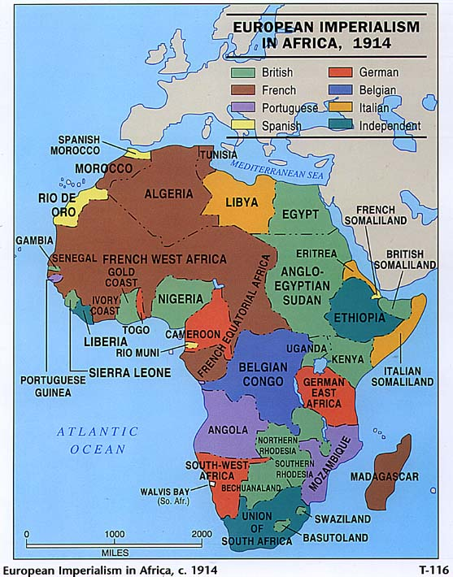
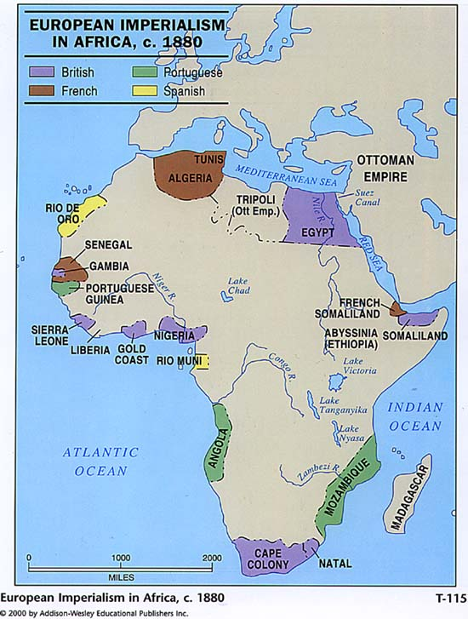
___________________________________________________________________________________________________________________________________________________________________________________________________________________________________________________________________________________________________________________________________________________

The Rationale:
- Think about the last two units (Revolutions, Industrial Revolution) - how did we get here?
- Nationalism - large colonies meant power
- Industrialization - vast access to natural resources and cheap labor
- Humanitarianism - Europeans thought it was their duty to civilize and uplift African people
- Social Darwinism - Survival of the fittest people
Nationalism (1800-1914):
- French Revolution and ____________________ spread nationalism throughout Europe
- Pride in one’s country was based upon industrial production, military strength, and size of _______________________
Industrialization (1750-1900):
- Increased ______________ in Europe
- Great technological advances - military, transportation, and communications
- Continued economic expansion requires more resources and markets
Humanitarianism:
- Christian missionaries saw Africa and Asia as fertile ground for ___________________
- Cultural superiority - Europeans must “save” the rest of the world
- Must stop the Arab slave trade in Africa (still in practice in North/East Africa)
Scramble for Africa:
- Prior to the Age of Imperialism, Europeans only controlled port towns
  - (except for Portugal who had two larger colonies)
- ___________________took South Africa, Sierra Leone, and Gambia in the mid-1800s
- Between 1875 and 1900 European control of Africa went from 10% to 90%
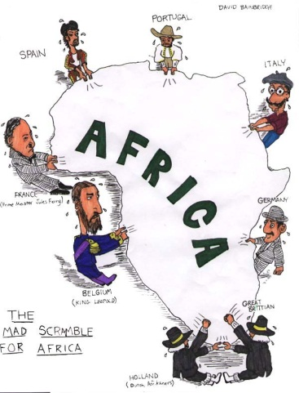
- Only two nations, Liberia (home to many freed American slaves) and Ethiopia remained independent
What is this picture communicating???
________________________________________________________________________________________________________________________________________________________________________________________________________________________________________________________________________________________________________________________________________________________________________________________________________________________________________________________________________________________________________

The Berlin Conference:
- European nations met in Berlin, Germany to settle arguments over ___________________lands
- European powers divided all of Africa (except Ethiopia and Liberia) and drew up new borders
  - Did not consider ethnic or language differences of African tribes
  - Africans had no say in the decisions
The Spanish-American War (1898):
- Causes
  - U.S. wanted to help Cuba win independence from Spain
    - U.S. had _____________________ interests in Cuba
    - U.S. saw Spain’s control of Cuba as a test of the Monroe Doctrine
      - Monroe Doctrine: stated that the Americas were off limits to further European colonization
  - U.S. wanted to build an empire
    - U.S. needed raw materials and markets for its goods
    - Strong nationalism
      - Americans wanted their nation to be powerful, wealthy, and competitive with the European powers
  - U.S. newspapers blamed Spain for explosion of USS Maine

- Effects
  - U.S. quickly defeated ___________________and became a world power
  - U.S. acquired Puerto Rico, Cuba, the Philippines, and Guam
    - U.S. temporarily occupied Cuba and set up a military government
    - Cuba and the Philippines eventually gained independence
Intervention in Latin America:
- Roosevelt Corollary to the Monroe Doctrine
  - Declared the U.S. as the police power of the Western Hemisphere
  - Established U.S. “economic imperialism” throughout Latin America
- Panama
  - U.S. supported Panama’s ________________________ from Colombia in exchange for the right to build and control the Panama Canal
Japan Opens Up:
- Since the 1600’s, Japan had practiced a policy of __________________________, in which it cut itself off from the outside world
- In the 1850’s, the United States__________________ forced Japan to open its ports to trade

