EXPLORATION
Let’s Review
- Why did European's explore by sea?
- Who were the two main players in exploration?
- What are the Three “G’s”?

Columbian Exchange
- describes the enormous exchange of plants, animals, foods, human populations (including slaves), diseases, and ideas between the Eastern and Western hemispheres that occurred after 1492.
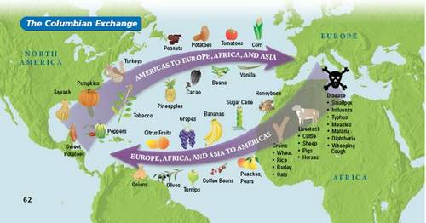
_______________________________________________________________________________________________________________________________________________________________________________________________________________________________________________________________________________________________________________________________________________________________________________________________________________________________________________________________________________________________________________________________________________________________________________________________________________

Middle Passage
- the forced transportation of African people from Africa to the New World as part of the Atlantic slave trade
- the middle portion of the triangular trade voyage.

Major Developments of Colonial Expansion:
- Political Developments
  - New forms of __________________ in colonial areas.
In your own words, describe the term POLITICAL and use an example.
_______________________________________________________________________________________________________________________________________________________________________________________________________________________________________________________________

SOCIAL DEVELOPMENTS

PEOPLE & RELIGION
- ___________________ Spreads to new lands
- ___________________ grew in America

Describe a specific social development.
____________________________________________________________________________________________________________________________________________________________________________________________________________________________________________________________________________________________________________________________________________________

ECONOMIC DEVELOPMENTS
- MONEY
  - Trade Routes shifts from Mediterranean Sea to the Atlantic Ocean.
  - Capitalism and Mercantilism are used to promote trade.
  - Increased IMPORTS

- MERCANTILISM
  - The belief that the wealth of a nation is based on its supply of _________ and ___________.
  - theory of trade fixed amount of gold export more than it ____________accumulate bullion (gold)
  - There is a fixed amount of wealth in the world and that in order to receive a larger share, one country has to _____________________________from another country.

What role did mercantilism play with the colonies?
- European powers aimed to colonize overseas lands that were rich in gold, silver, and raw materials that could __________________________ at home.
- A powerful nation sought to buy raw materials from its ______________________.

What does this picture mean?
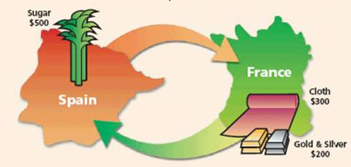
____________________________________________________________________________________________________________________________________________________________________________________________________________________________________________________________________________________________________________________________________________________________________________

- One of the main reasons why European nations colonized new areas was because they believed in mercantilism. This system was based on the idea that a nation made money by exporting more goods than it imported. European nations did whatever they could to secure that.

CAPITALISM
- Private ownership of a business. The goal is to make ______________!
- Production for Profit!
- Powerful nations like Britain, France, and Spain realized that they could increase their exports and revenue by colonizing new areas. The colonized nations were forced to import the goods of the Mother Country, and the colonists were heavily taxed.

This system had positive and negative outcomes.

Advantages | Disadvantages
 | 2.)
 | 3.)

Colonies were set up in America by:
- ______________
- ______________
- ______________
- ______________
But what were the colonists looking for?
1.)
2.)
3.)
What were the mother countries looking for?
- Wanted colonies to give them _________, __________, __________, and _______________!

