Attitude towards War:
- “The whole idea was to get a hold of a rifle, learn to shoot a bit, proceed to France at the earliest possible moment, kill vast quantities of Germans, possible get wounded in some artistic place, win the war and march back with colors flying and bands playing and the girls falling on your neck.”
- Captain Allan Goring
- What does that mean? (In your own words)
  - ____________________________________________________________________________________________________________________________________
__________________________________________________________________

Attitudes quickly changed when soldiers were faced with the warfare and weapons of war.
- From the video. (In your own words)
  - ____________________________________________________________________________________________________________________________________
__________________________________________________________________

Where was the Western Front?
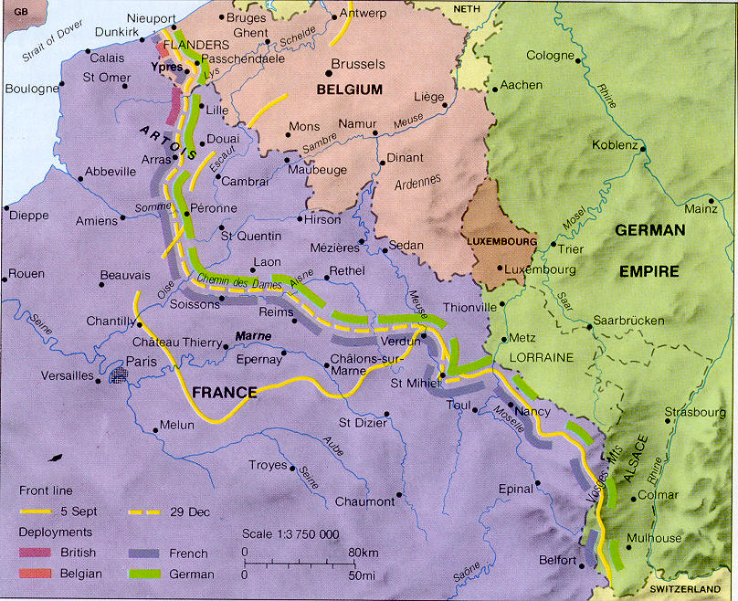

What type of Warfare was used on the Western Front?
- Trench Warfare

What were some of the problems with this type of warfare?
- 1.)_________________
- 2.)_________________

- Trenchfoot
- Rats

What was the area between opposing sides trenches called?
- _____________________________

What impact did trench warfare have on the war?
Casualties
Allied | Central
- 42 Million men mobilized  - 5 million killed  - 13 million wounded  - 4 million POW’s and missing  - 22 million total casualties  - 52% of men mobilized | - 65 Million men mobilized  - 8.5 million killed  - 21 million wounded  - 7.7 million POW’s and missing  - 37 million total casualties  - 57% of men mobilized

Total Casualties:
- 107 Million men mobilized
- 13.5 million killed
- 34 million wounded
- 11.7 million POW’s and missing
- 59 million total casualties
- 55% of men mobilized

What were the new war technologies used in WWI?
- Machine Gun
- Tank
- Airplane
- Poisonous Gas
  - Mustard Gas
  - Chlorine Gas
  - 20-30% of all casualties were due to gas

Impact on Soldiers
- “I had just got a pan full of slum and started eating when I saw part of the temporary trench which I had left screened by an exploding shell. I thought it had come over the trench, but no- just then Smithy and Neterfield jumped out calling for stretchers. I dropped my mess and ran to the trench and looked in. Poor Art was dead, one arm completely severed from his body. Danny had a whole in his stomach and we placed him on a stretcher and sent him back to the first aid station.”
- Corporal Sherwood

