Congress of Vienna:
- After Napoleon’s defeat, European leaders met in ____________ and decided that:
  - France should be ____________________
  - the countries around it were made stronger
  - ______________________-No country would be able to overpower another
  - France was punished, but not excessively so it wouldn’t want_________________.
  - Restore Monarchies (France, Spain, and parts of Italy)
  - During Peninsular War, Napoleon deposed the King of Spain.
Legacy of the Congress of Vienna:
- France ____________ and weaker
- People begin to see democracy as a way to have equality and __________________________.
- Power of Prussia and Great Britain increase
Why did the people of Latin America want a Revolution?
- New Enlightenment ideas spread to the people of Latin America
- Inspiration from __________________and __________________________ Revolutions
- ____________, _______________ and _________________ were fighting and left no time or efforts for their Latin American Colonies
- Continuation of Brutal slavery in places where slaves outnumbered free men.
- Colonial Society had a class system that severely limited your ____________ unless you were born in Europe and then moved to Latin America
- Spanish Colonies did not support a _________________________ as their Spanish king.
- Napoleon put his __________________Joseph in power after removed Spain's true king Ferdinand VII.

Your Turn…

Toussaint L’Ouveture:
- Slaves Revolt on the _________________________ of the island of Hispaniola (controlled by the French) because they want ___________________
- _________________________________________ leads the revolt
- War ensues with the French
- Slaves win their independence and the territory becomes known as______________ in 1804
Simón Bolivar:
- Creole (Spaniard born in Latin America) leader of _________________________in Latin America.
- Spent time in Europe and the newly-independent ______________________________.
- Leads a volunteer army of revolutionaries against the _____________________army.
- A victory for the revolution eventually leaves the future countries of Venezuela, Columbia, Panama, and Ecuador united into one large country called ____________________________.
Bolivar’s Accomplishment:

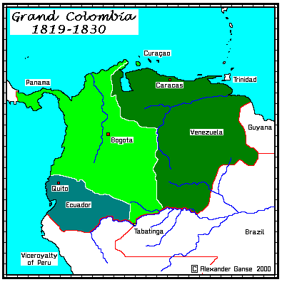
___________________________________________________________________________________________________________________________________________________________________________________________________________________________________________________________________________________________________________________________

José de San Martin:
- Works with Simon Bolivar to __________________much of South America
- Argentina declares______________________ in ____________
- Helps ________ and _____________ win their independence from Spain.
Padre Miguel Hidalgo:
- A priest in a small village of Delores
- Was the first person that started the ___________________________________________.
- He started a volunteer army to march to ____________________ that grew to 80,000 men.
- However the men were ________________________ by the Spanish Army

Agustin de Iturbide:
- Mexico’s ___________________________ thought they would lose their special privileges when a revolution started in Spain.
- So they united in support of ________________________.
- Agustin de Iturbide, a Creole and officer of the Spanish army, proclaimed independence from ______________ in 1821.
- He then declared himself ___________________ of the newly formed nation, but was later overthrown.
Prince (King) John VI:
- Prince and then later king of _______________________.
- Escaped Napoleon’s armies by fleeing Spain and taking entire treasury and royal court to ____________________, Portugal's largest colony.
- After Napoleon’s defeat 6 years later they returned to __________________.
- _____________________________signed a petition for Brazil’s independence from Portugal.
- King ____________________ signed the petition without bloodshed.

Latin American Countries after the Revolutions:
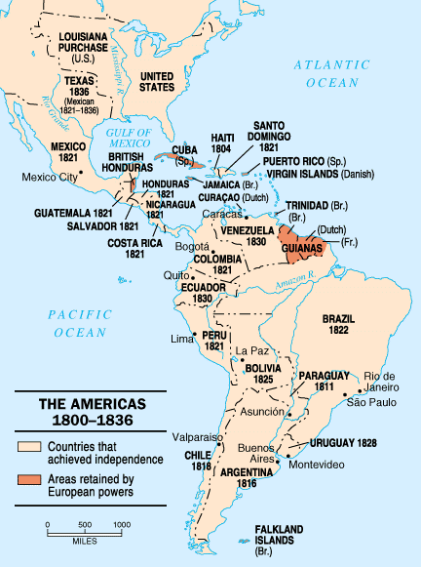
What do you notice about this map?
______________________________________________________________________________________________________________________________________________________________________________________________________________________________________________________________________________________________________________________________________________________________________________________________________________________________

