What’s Your Take?
Examine the cartoons below and write a brief statement in your own words as to what you think that artist was trying to convey. Be prepared to share your thoughts in class.

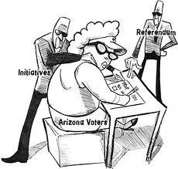
________________________________________________________________________________________________________________________________________________________________________________________________________________________________________________________________________________________________________________________________________________________________________________________________________________________________________________________________________________________________

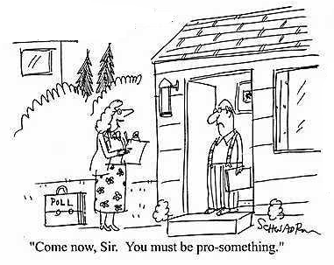
________________________________________________________________________________________________________________________________________________________________________________________________________________________________________________________________________________________________________________________________________________________________________________________________________________________________________________________

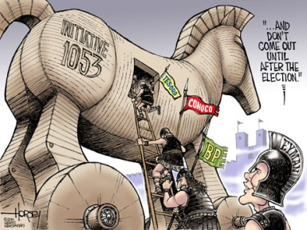
____________________________________________________________________________________________________________________________________________________________________________________________________________________________________________________________________________________________________________________________________________________________________________________________________________________________________
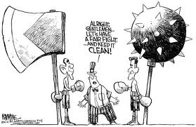
_____________________________________________________________________________________________________________________________________________________________________________________________________________________________________________________________________________________________

The Cartoonist in You!
It’s your turn to show off your artistic skills. In the box below draw your own cartoon. Think about what we discussed in class about Initiatives, Referenda’s, Recalls, and Clean Elections and create a cartoon that reflects your personal views and opinions.

What does this cartoon mean to you?
__________________________________________________________________________________________________________________________________________________________________________________________________________________________________________________________________________________________________________________________________________________________________________________________________________________________________________________________________________________________________________________________________________________________________
Teachers Notes: (do not write in this section)
__________________________________________________________________________________________________________________________________________________________________________________________________________________________________________

